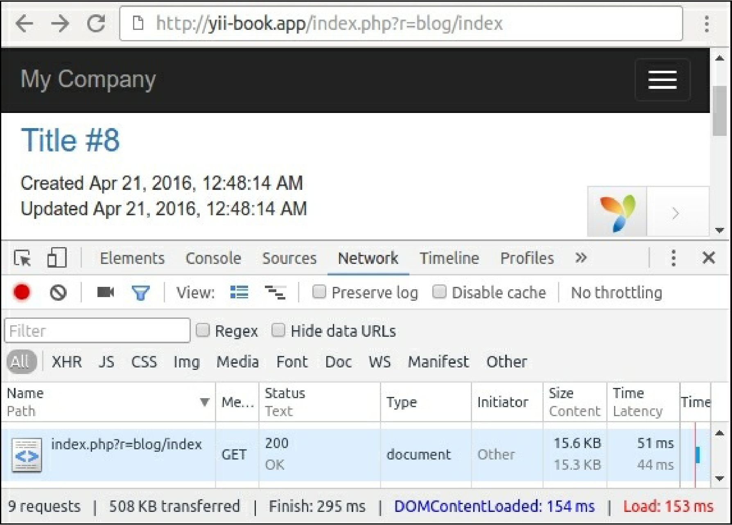

1. Open BlogController and attach the following behaviors:

class BlogController extends Controller {

public function behaviors()

{

return [

[

'class' => 'yii\filters\HttpCache',

'only' => ['index'],

'lastModified' => function ($action, $params) { return Article::find()->max('updated_at');

},

],

[

'class' => 'yii\filters\HttpCache',

'only' => ['view'],

'etagSeed' => function ($action, $params) {

$article = $this->findModel(\Yii::$app->request->get('id')); return serialize([$article->title, $article->text]);

},

],

];

}

// ...

}